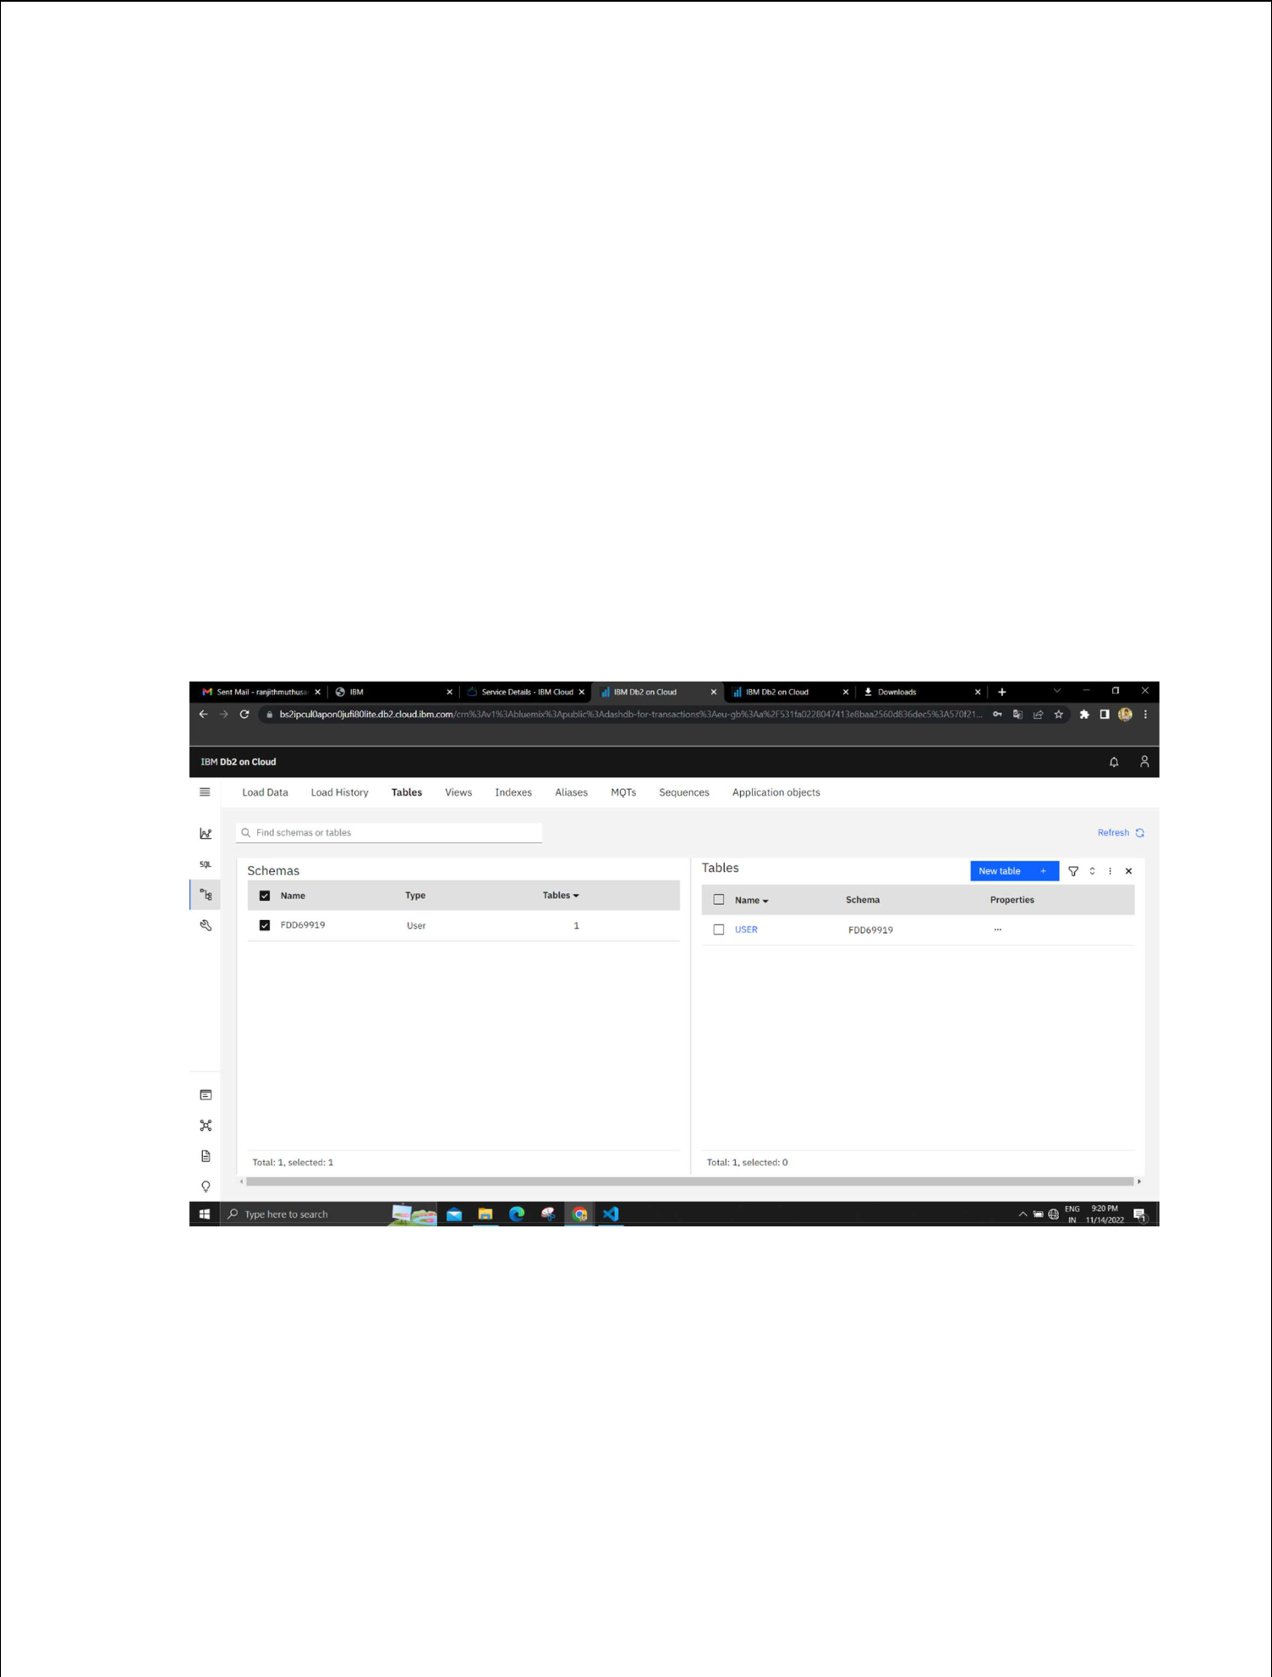
Assignment 2

Inventory Management System:

Team ID : PNT2022TMID05660
Name : Mohamed Fazil

- Create User table with user with email, username, roll number, password.
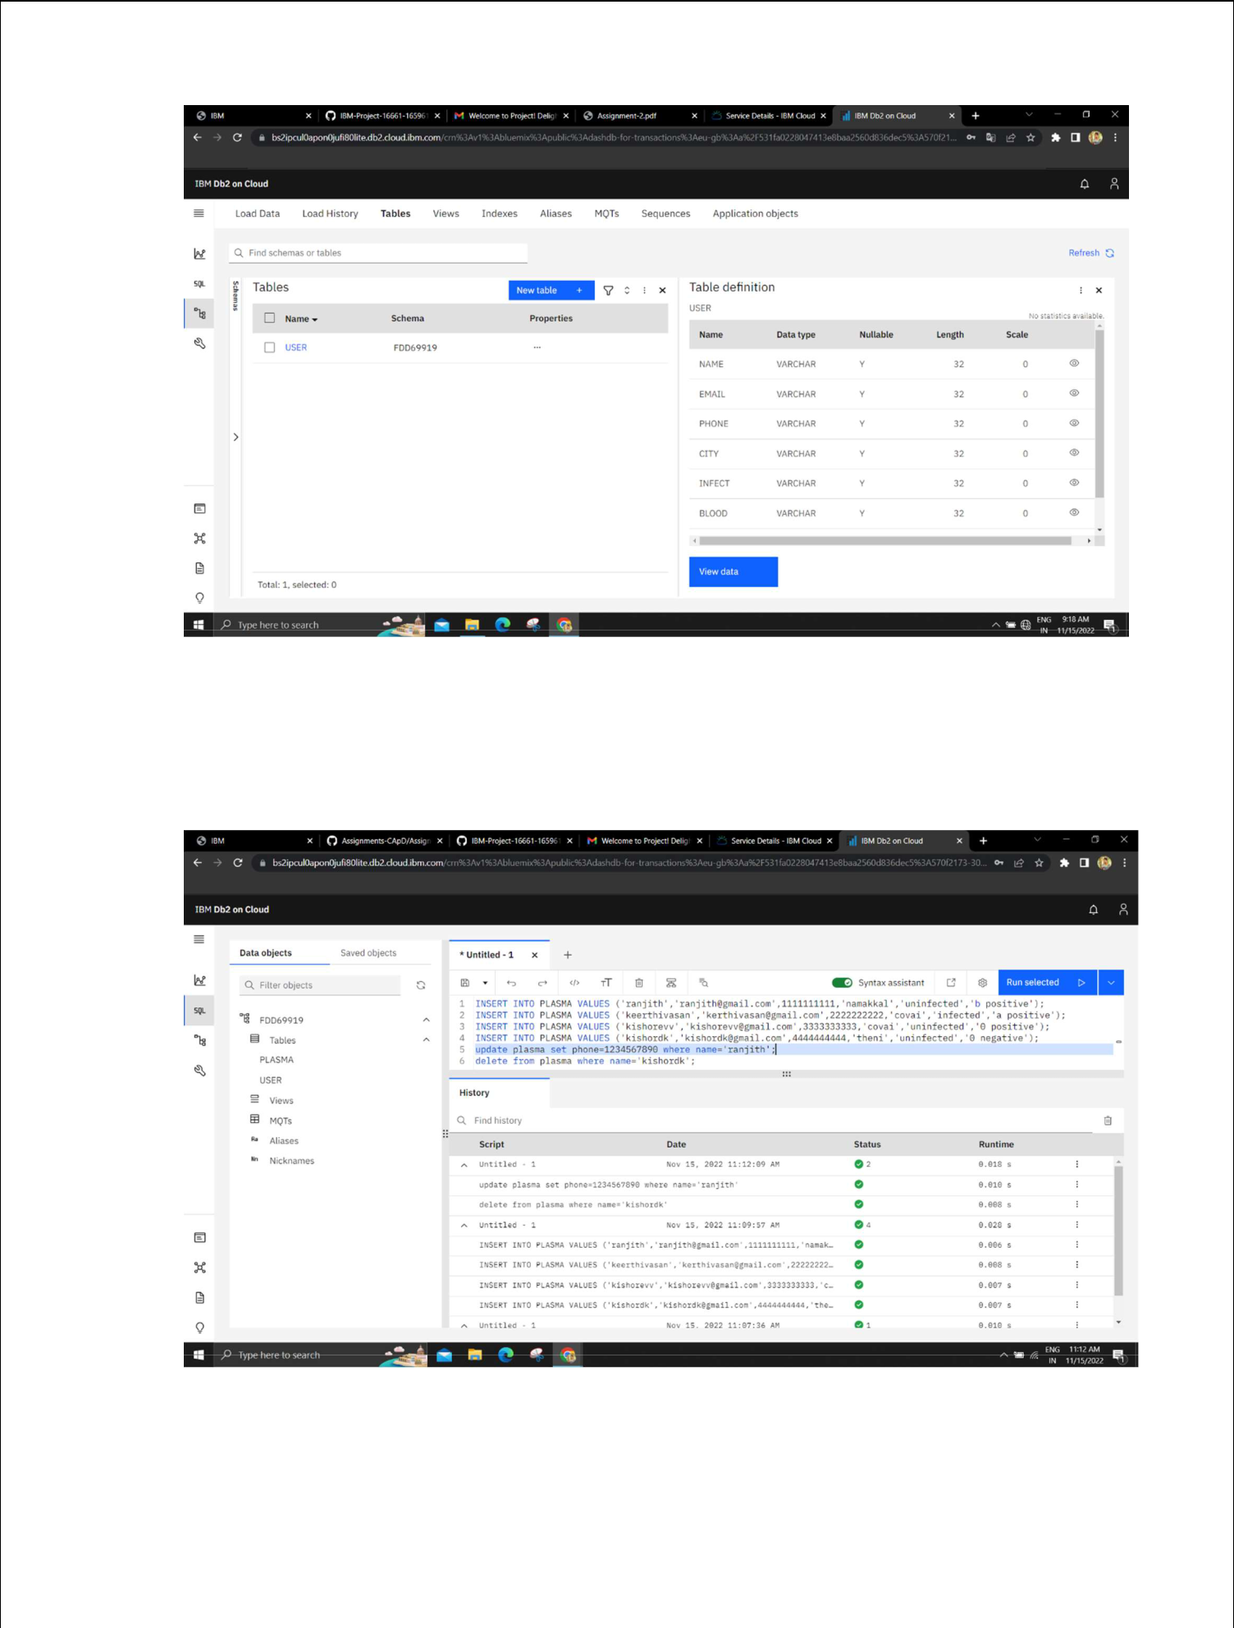

2. Perform UPDATE, DELETE Queries with user table.
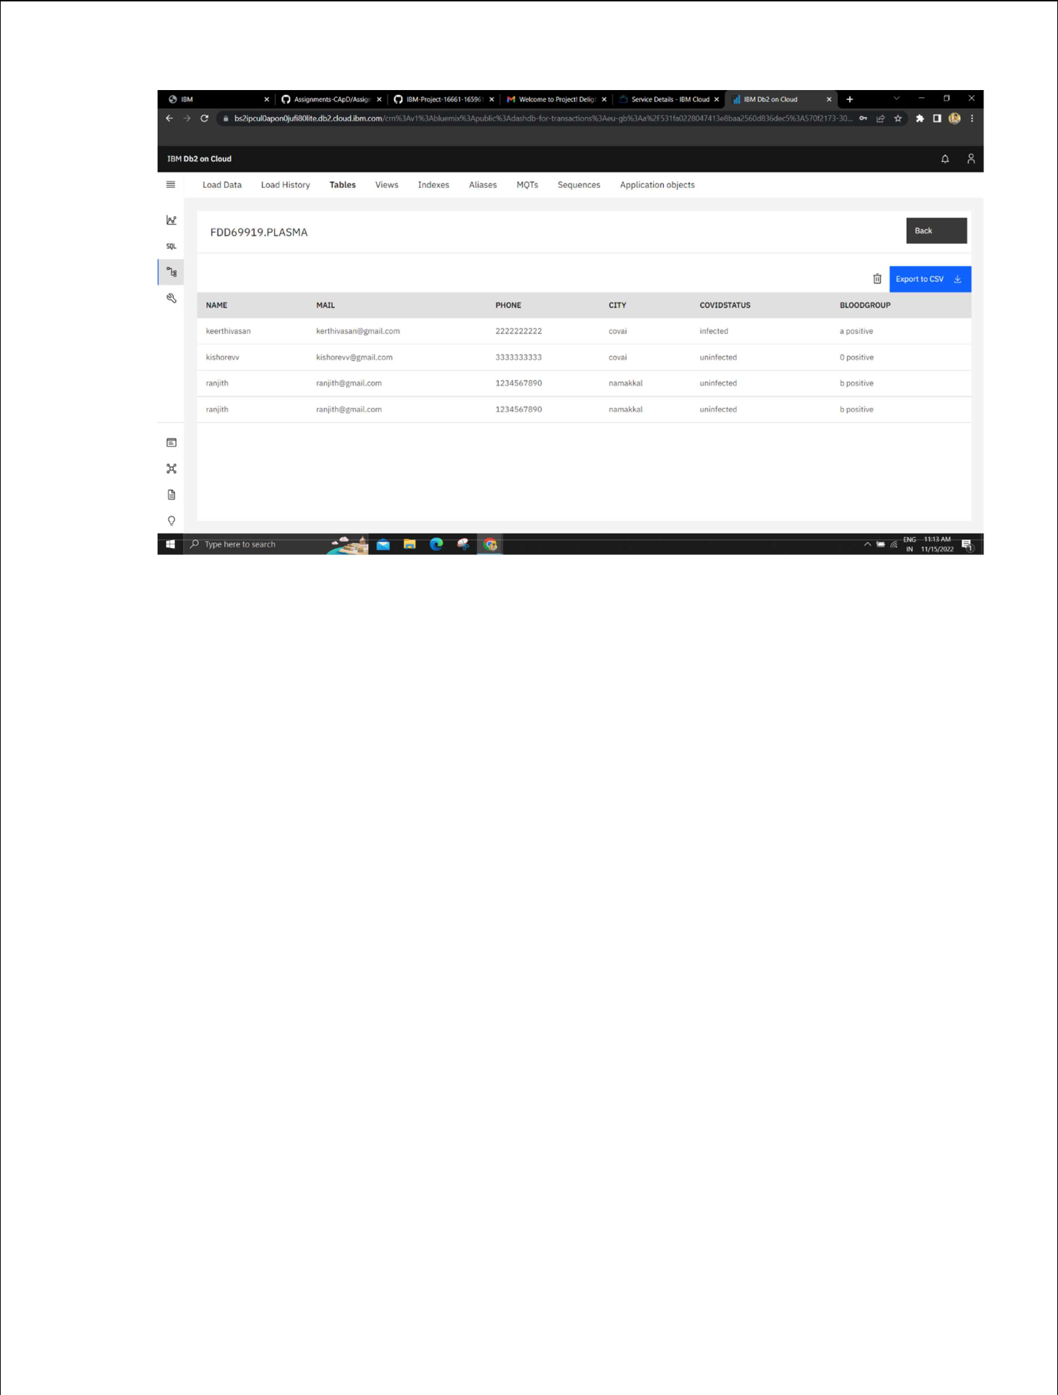

3. Connect python code to db2.

DB:

conn = ibm_db.connect("DATABASE=bludb;

HOSTNAME=55fbc997-9266-4331-afd3-

888b05e734c0.bs2io90l08kqb1od8lcg.databases.appdomain.cloud;PORT=31929;SECUR

ITY=SSL;SSLServerCertificate=DigiCertGlobalRootCA.crt;UID=fdd69919;PWD=AlJ8I

eJp3OlE98qL",'','')
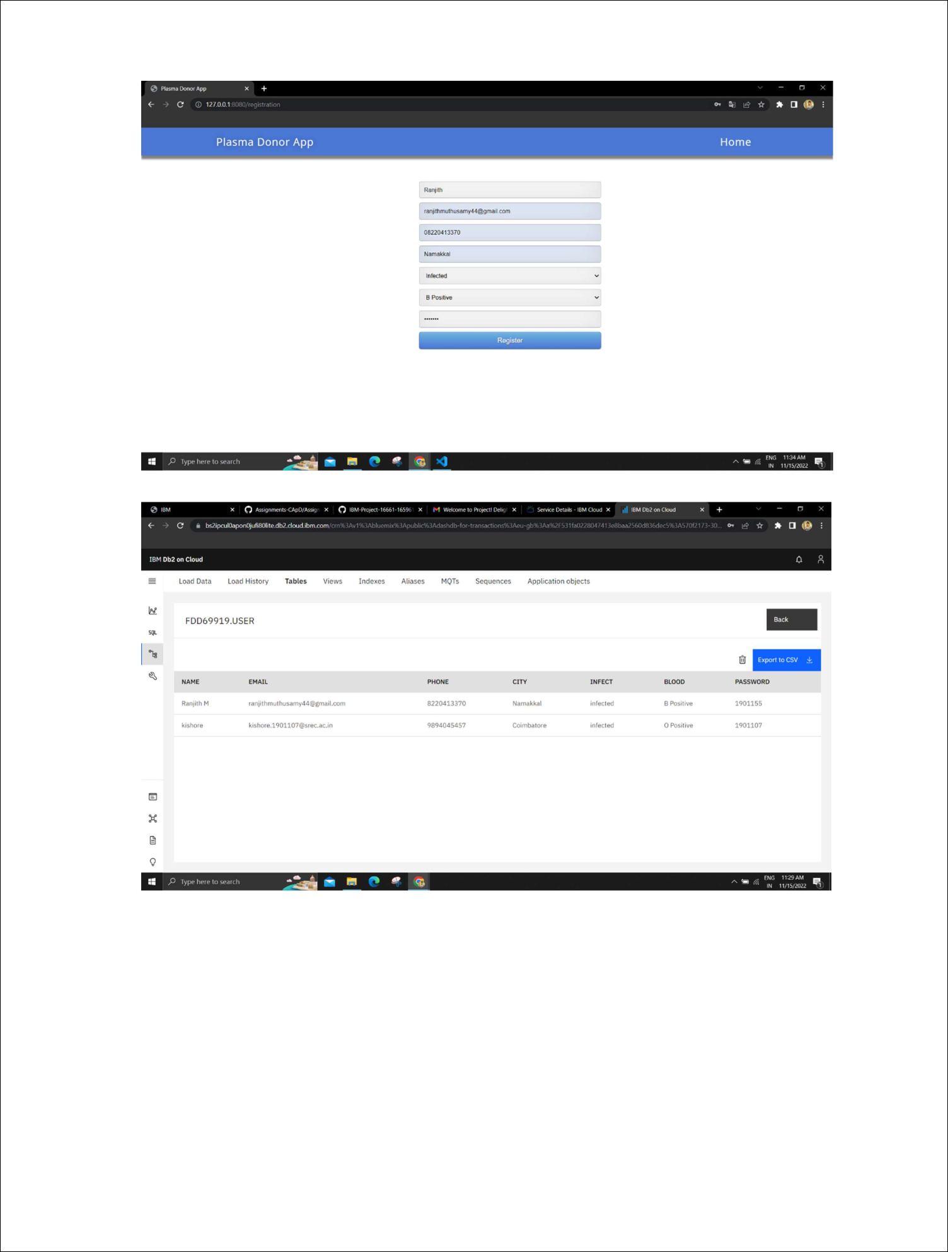

- Create a flask app with registration page, login page and welcome page. By default load the registration page once the user enters all the fields store the data in database and navigate to login page authenticate user username and password. If the user is valid show the welcome page.

Solution:

Register.html

<!DOCTYPE html>

<html >

<!--From https://codepen.io/frytyler/pen/EGdtg--> <head>

<meta charset="UTF-8">

<title>Plasma Donor App</title>

<link href='https://fonts.googleapis.com/css?family=Pacifico' rel='stylesheet' type='text/css'>

<link href='https://fonts.googleapis.com/css?family=Arimo' rel='stylesheet' type='text/css'>

<link href='https://fonts.googleapis.com/css?family=Hind:300' rel='stylesheet' type='text/css'>

<link href='https://fonts.googleapis.com/css?family=Open+Sans+Condensed:300' rel='stylesheet' type='text/css'>

<link rel="stylesheet" href="{{ url_for('static', filename='style1.css') }}"> <!link rel="stylesheet" href="style.css">

<style>

.login{

top: 20%;

}

</style>

</head>

<body>

<div class="header">

<div>Plasma Donor App</div>

<ul>

<li><a class="active" href="/login">Home</a></li> </ul>

</div>

<div class="login">

<!-- Main Input For Receiving Query to our ML -->

<form action="{{ url_for('register')}}"method="post">

<input type="text" name="name" placeholder="Enter Your Name" required="required" style="color:black"/>

<input type="email" name="email" placeholder="Enter Email" required="required" style="color:black"/>

<input type="text" name="phone" placeholder="Enter 10-digit mobile number" required="required" style="color:black"/>

<input type="city" name="city" placeholder="Enter Your City Name" required="required" style="color:black"/>

<select name="infect">

<option value="select" selected>Select COVID infection

status</option>

<option value="infected">Infected</option>

<option value="uninfected">Uninfected</option>

</select>

<select name="blood">

<option value="select" selected>Choose your blood

group</option>

<option value="O Positive">O Positive</option> <option value="A Positive">A Positive</option> <option value="B Positive">B Positive</option> <option value="AB Positive">AB Positive</option> <option value="O Negative">O Negative</option> <option value="A Negative">A Negative</option> <option value="B Negative">B Negative</option> <option value="AB Negative">AB Negative</option>

</select>

<input type="password" name="passw" placeholder="Enter Password" required="required" style="color:black"/>

<button type="submit" class="btn btn-primary btn-block btn-large">Register</button>

</form>

<br><br>

<div style="color:black">

{{ pred }}</div> </div>

</body>

</html>

Login.html

<!DOCTYPE html>

<html >

<!--From https://codepen.io/frytyler/pen/EGdtg--> <head>

<meta charset="UTF-8">

<title>Plasma Donor App</title>

<link href='https://fonts.googleapis.com/css?family=Pacifico' rel='stylesheet' type='text/css'>

<link href='https://fonts.googleapis.com/css?family=Arimo' rel='stylesheet' type='text/css'>

<link href='https://fonts.googleapis.com/css?family=Hind:300' rel='stylesheet' type='text/css'>

<link href='https://fonts.googleapis.com/css?family=Open+Sans+Condensed:300' rel='stylesheet' type='text/css'>

<link rel="stylesheet" href="{{ url_for('static', filename='style1.css') }}"> <!link rel="stylesheet" href="style.css">

<style>

.login{

top: 20%;

}

</style>

</head>

<body>

<div class="header">

<div>Plasma Donor App</div>

<ul>

<li><a href="/registration">Register</a></li>

<li><a class="active" href="/login">Home</a></li> </ul>

</div>

<div class="login" >

<div>

</div>

<!-- Main Input For Receiving Query to our ML -->

<form action="{{ url_for('loginpage')}}"method="post">

<input type="text" name="user" placeholder="Enter UserName" required="required" style="color:black" />

<input type="password" name="passw" placeholder="Enter Password" required="required" style="color:black" />

<button type="submit" class="btn btn-primary btn-block btn-large">Login</button>

</form>

<br><br>

<div style="color:black">

{{ pred }}</div> </div>

</body>

</html>

Style.css

@import url(https://fonts.googleapis.com/css?family=Open+Sans);

.btn {

display: inline-block;

*display: inline;

*zoom: 1; padding:

4px 10px 4px;

margin-bottom: 0;

font-size: 13px;

line-height: 18px;

color: #333333;

text-align: center;

text-shadow: 0 1px 1px rgba(255, 255, 255, 0.75);

vertical-align: middle;

background-color: #f5f5f5;

background-image: -moz-linear-gradient(top, #ffffff, #e6e6e6);

background-image: -ms-linear-gradient(top, #ffffff, #e6e6e6);

background-image: -webkit-gradient(linear, 0 0, 0 100%, from(#ffffff), to(#e6e6e6));

background-image: -webkit-linear-gradient(top, #ffffff, #e6e6e6);

background-image: -o-linear-gradient(top, #ffffff, #e6e6e6);

background-image: linear-gradient(top, #ffffff, #e6e6e6);

background-repeat: repeat-x;

filter: progid:dximagetransform.microsoft.gradient(startColorstr=#ffffff, endColorstr=#e6e6e6, GradientType=0);

border-color: #e6e6e6 #e6e6e6 #e6e6e6;

border-color: rgba(0, 0, 0, 0.1) rgba(0, 0, 0, 0.1) rgba(0, 0, 0, 0.25);

border: 1px solid #e6e6e6;

-webkit-border-radius: 4px;

-moz-border-radius: 4px;

border-radius: 4px;

-webkit-box-shadow: inset 0 1px 0 rgba(255, 255, 255, 0.2), 0 1px 2px rgba(0, 0, 0, 0.05);

-moz-box-shadow: inset 0 1px 0 rgba(255, 255, 255, 0.2), 0 1px 2px rgba(0, 0, 0, 0.05);

box-shadow: inset 0 1px 0 rgba(255, 255, 255, 0.2), 0 1px 2px rgba(0, 0, 0, 0.05);

cursor: pointer; *margin-left: .3em;

}

.btn:hover, .btn:active, .btn.active, .btn.disabled, .btn[disabled] { background-color: #e6e6e6; }

.btn-large {

padding: 9px 14px;

font-size: 15px;

line-height: normal;

-webkit-border-radius: 5px;

-moz-border-radius: 5px;

border-radius: 5px;

}

.btn:hover {

color: #333333;

text-decoration: none;

background-color: #e6e6e6;

background-position: 0 -15px;

-webkit-transition: background-position 0.1s linear;

-moz-transition: background-position 0.1s linear;

-ms-transition: background-position 0.1s linear;

-o-transition: background-position 0.1s linear;

transition: background-position 0.1s linear;

}

.btn-primary, .btn-primary:hover { text-shadow: 0 -1px 0 rgba(0, 0, 0, 0.25); color: #ffffff;

}
.btn-primary.active { color: rgba(255, 255, 255, 0.75); }

.btn-primary {

background-color: #4a77d4;

background-image: -moz-linear-gradient(top, #6eb6de, #4a77d4);

background-image: -ms-linear-gradient(top, #6eb6de, #4a77d4);

background-image: -webkit-gradient(linear, 0 0, 0 100%, from(#6eb6de), to(#4a77d4));

background-image: -webkit-linear-gradient(top, #6eb6de, #4a77d4);

background-image: -o-linear-gradient(top, #6eb6de, #4a77d4);

background-image: linear-gradient(top, #6eb6de, #4a77d4);

background-repeat: repeat-x;

filter: progid:dximagetransform.microsoft.gradient(startColorstr=#6eb6de, endColorstr=#4a77d4, GradientType=0);

border: 1px solid #3762bc;

text-shadow: 1px 1px 1px rgba(0,0,0,0.4);

box-shadow: inset 0 1px 0 rgba(255, 255, 255, 0.2), 0 1px 2px rgba(0, 0, 0, 0.5);

}

.btn-primary:hover, .btn-primary:active, .btn-primary.active, .btn-primary.disabled, .btn-primary[disabled] {

filter: none;

background-color: #4a77d4;

}

.btn-block { width: 100%; display:block; }

- { -webkit-box-sizing:border-box; -moz-box-sizing:border-box; -ms-box-sizing:border-box; -o-box-sizing:border-box; box-sizing:border-box; }

html { width: 100%; height:100%; overflow:hidden; }

body {

width: 100%;

height:100%;

font-family: 'Open Sans', sans-serif;

background: #fffff;

color: #000000;

font-size: 18px;

text-align:center;

letter-spacing:1.2px;
}

.header {

top:0;

margin:0px;

left: 0px;

right: 0px;

position: fixed;

background: #4a77d4;

color: white;

box-shadow: 0px 8px 4px grey;

overflow: hidden;

padding: 15px;

font-size: 1.5vw;

width: 100%;

text-align: center;

}

.login {

position: absolute;

top: 70%;

left: 50%;

margin: -25px 0 0 -150px;

width:400px;

height:400px;

}

.header div { color: #fff; text-shadow: 0 0 10px rgba(0,0,0,0.3); letter-

spacing:1px; text-align:center; float:left; padding-left:150px;}

ul {

list-style-type: none;

margin: 0;

padding: 0;

padding-right:150px;

overflow: hidden;

}

li {

float: right;

}

li a {

display: block;

color: white;

text-align: center;

padding: 0px 15px;

text-decoration: none;

}

input {

width: 100%;

margin-bottom: 10px;

background: rgba(255,255,255,255);

border: none;

outline: none;

padding: 10px;

font-size: 13px;

color: black;

text-shadow: black;

border: 1px solid rgba(0,0,0,0.3);

border-radius: 4px;

box-shadow: inset 0 -5px 45px rgba(100,100,100,0.2), 0 1px 1px rgba(255,255,255,0.2);

-webkit-transition: box-shadow .5s ease;

-moz-transition: box-shadow .5s ease;

-o-transition: box-shadow .5s ease;

-ms-transition: box-shadow .5s ease;

transition: box-shadow .5s ease;

}

input:focus { box-shadow: inset 0 -5px 45px rgba(100,100,100,0.4), 0 1px 1px rgba(255,255,255,0.2); }

select {

width: 100%;

margin-bottom: 10px;

background: rgba(255,255,255,255);

border: none;

outline: none;

padding: 10px;

font-size: 13px;

color: #000000;

text-shadow: 1px 1px 1px rgba(0,0,0,0.3);

border: 1px solid rgba(0,0,0,0.3);

border-radius: 4px;

box-shadow: inset 0 -5px 45px rgba(100,100,100,0.2), 0 1px 1px rgba(255,255,255,0.2);

-webkit-transition: box-shadow .5s ease;
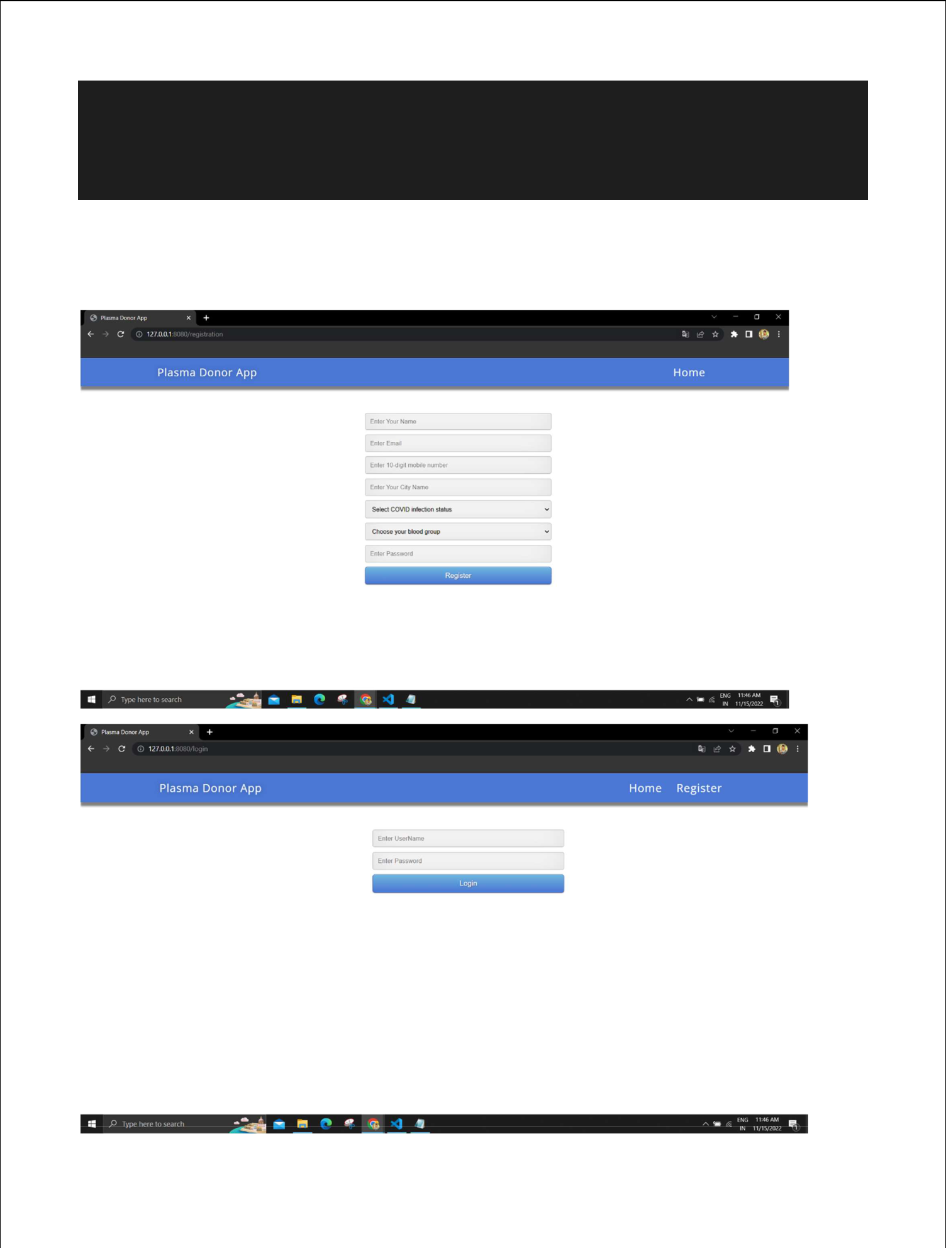
-moz-transition: box-shadow .5s ease;

-o-transition: box-shadow .5s ease;

-ms-transition: box-shadow .5s ease;

transition: box-shadow .5s ease;

}
